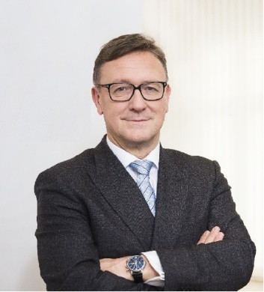 | Calendar of Helmut Ettl  Member of the Supervisory Board of the Single Supervisory Mechanism  Executive Director of the Austrian Financial Market Authority  March 2024
Date | Meeting / Event | Location
Friday, 8 March | Meeting with a representative of U.S. Department of Treasury | Vienna
Tuesday, 12 March | Financial Markets Stability Board Meeting | Vienna
Thursday, 14 March | Participation in the Financial Committee Meeting of the Austrian Parliament | Vienna
Thursday, 14 March | Meeting with supervised entity | Vienna
Tuesday, 19 March | Supervisory Board Meeting | Frankfurt
Wednesday, 20 March | Supervisory Board Meeting | Frankfurt
Thursday, 21 March | ESRB Meeting | Virtual
Wednesday, 27 March | Meeting with a banking association | Vienna

The calendar gives information on Helmut Ettl’s meetings in his capacity as a member of the ECB’s Supervisory Board. It includes institutional meetings, speaking engagements, attendance at conferences and events, as well as appointments with external parties (incl. media), unless releasing the information could undermine the protection of public interests recognised at EU level. Internal Eurosystem meetings are not published.

