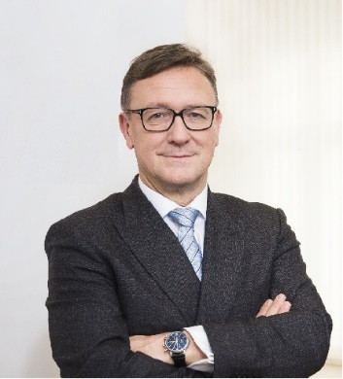 | Calendar of Helmut Ettl  Member of the Supervisory Board of the Single Supervisory Mechanism  Executive Director of the Austrian Financial Market Authority  February 2024
Date | Meeting / Event | Location
Thursday, 1 February | Supervisory Board Meeting | Frankfurt
Tuesday, 6 February | Visit to Austria of the Chair of the SSM Supervisory Board | Vienna
Wednesday, 7 February | Visit to Austria of the Chair of the SSM Supervisory Board | Vienna
Friday, 9 February | Meeting with supervised entity | Virtual
Thursday, 15 February | ECB Banking Supervision Market Contact Group | Frankfurt
Monday, 19 February | Meeting with private sector | Vienna
Thursday, 22 February | Speaker at the EUROFI Conference | Ghent
Monday, 26 February | Supervisory Board Meeting | Virtual

The calendar gives information on Helmut Ettl’s meetings in his capacity as a member of the ECB’s Supervisory Board. It includes institutional meetings, speaking engagements, attendance at conferences and events, as well as appointments with external parties (incl. media), unless releasing the information could undermine the protection of public interests recognised at EU level. Internal Eurosystem meetings are not published.

