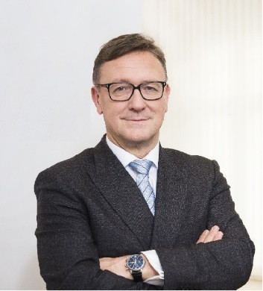 | Calendar of Helmut Ettl  Member of the Supervisory Board of the Single Supervisory Mechanism  Executive Director of the Austrian Financial Market Authority  September 2023
Date | Meeting / Event | Location
Monday, 4 September | IWF Staff Visit | Vienna
Wednesday, 6 September | Participation at Finanzcockpit (hosted by OeNB) | Virtual
Thursday, 7 September | Bilateral Meeting with Albanian Financial Supervisory Authority (AFSA) | Vienna
Tuesday, 12 September | EBA BoS Meeting | Virtual
Tuesday, 12 September | Meeting of the Steering Committee of the Supervisory Board | Virtual
Friday, 15 September | Speaker at the EUROFI Conference | Santiago de Compostela
Monday, 18 September | Meeting with media representatives | Vienna
Monday, 25 September | EBA MB Meeting | Virtual
Wednesday, 27 September | Welcoming Remarks at AML/CFT-College Conference for CESEE, organized by FMA | Vienna
Wednesday, 27 September | Meeting with Supervised Entity | Vienna

The calendar gives information on Helmut Ettl’s meetings in his capacity as a member of the ECB’s Supervisory Board. It includes institutional meetings, speaking engagements, attendance at conferences and events, as well as appointments with external parties (incl. media), unless releasing the information could undermine the protection of public interests recognised at EU level. Internal Eurosystem meetings are not published.

